TITLE PAGE
Disentangling influence over group speed and direction reveals multiple patterns of influence in moving meerkat groups

Baptiste Averly^{1,2,3,5}, Vivek H. Sridhar^{2,3,}, Vlad Demartsev^{1,2,5}, Gabriella Gall^{1,2,3,4,5,6}, Marta B, Manser^{4,5,7*}, Ariana Strandburg-Peshkin^{1,2,3,4,5*}

- Department of Biology, University of Konstanz, Konstanz, Germany
- Department for the Ecology of Animal Societies, Max Planck Institute of Animal Behavior, Konstanz, Germany
- Centre for the Advanced Study of Collective Behaviour, University of Konstanz, Konstanz, Germany
- Department of Evolutionary Biology and Environmental Studies, University of Zurich, Zurich, Switzerland
- Kalahari Meerkat Project, Kuruman River Reserve, Northern Cape, South Africa
- Zukunftskolleg, University of Konstanz, Konstanz, Germany
- Mammal Research Institute, University of Pretoria, South Africa

*joint senior author

ABSTRACT
Animal groups that move together must constantly come to consensus on both the direction and speed of movement, often reaching these two types of decisions simultaneously. Contributions to collective decisions may vary among group members, yet inferring who has influence over group decisions is challenging, largely due to the multifaceted nature of influence. Here we collected high-resolution (1 Hz) GPS data from five habituated meerkat groups during foraging in their natural habitat and developed a method to quantify individuals’ influence over both group direction and speed. We found that individuals’ influence over direction and speed were correlated, but also exhibited substantial variation. Comparing patterns across social status classes reveals that dominant females had disproportionately high influence over group direction compared to other individuals, but less consistent influence over group speed. Individuals with high influence were also not necessarily the ones who spent more time in the front of the group, challenging this common assumption. Our results emphasize the importance of integrating multiple perspectives when inferring influence over group decisions, and provide a general approach which can be applied to other species.

INTRODUCTION
In social animals, individuals often make heterogenous contributions to group decisions. Group members whose actions cause others to change their behavior can be said to exert influence, and the distribution and consistency of influence can vary across decision types, contexts, and species (Strandburg-Peshkin et al. 2018; Garland et al. 2018). Studies of influence over collective movement have been looking separately at questions such as who has influence over direction of travel (Kerth et al. 2006; Nagy et al. 2010; Giuggioli et al. 2015; Pettit et al. 2015), who has influence over timing of departure (Strandburg-Peshkin et al. 2015; Tokuyama and Furuichi 2017; Montanari et al. 2021), or who is in the front of the group (King et al. 2008; Lewis et al. 2011; Van Belle et al. 2013; Smith et al. 2015). A positive link between influence and social rank has often been established (reviewed in Smith et al., 2015), though systems with influential subordinates are also found (Papageorgiou and Farine 2020). Thus, there is a diversity of movement decisions-making mechanisms in nature, from systems where influence is mostly shared to systems where it is mostly unshared, depending on group characteristics such as size and composition, social structure, or type of movement (Boinski 2000; Conradt and Roper 2005; Conradt and Roper 2009).
Because of this diversity, assessing influence patterns and comparing them between social groups remains challenging. In order to correctly define and quantify influence in a social system, one has to first identify the decision-making mechanisms at play and the type of cues from a given individual that are of particular relevance in influencing the decisions of others (Strandburg-Peshkin et al. 2018). In the context of movement, these cues can include an individual’s position in space, its movement in a given direction, while signals include for example the production of vocalizations. Individual influence may also vary depending on the type of decision being considered. In particular, theoretical work has emphasized a fundamental distinction between decisions about movement direction and decisions about movement timing. These two types of decisions expected to have different distributions of consensus costs, leading to contrasting predictions about whether they are likely to be shared or unshared (Byrne 2000; Conradt and Roper 2010). It can be particularly challenging to disentangle these two types of influence, as both may occur at the same time when groups travel collectively, continuously needing to come to consensus on both the direction and speed of travel. Very few field studies investigated several measures of influence simultaneously within one system, for evaluating the consistency of individual influence over direction and speed of travel, as well as the contribution to the frontmost position for influencing group movement decisions (but see Herbert-Read et al. 2011; Katz et al. 2011; Jolles et al. 2017 for lab experiments). The versatile notion of influence makes it, crucial to define the context in which it is assessed, while also accounting for the biology and social structure of the study system.
We investigated influence dynamics in meerkats (Suricata suricatta), social mongooses living in highly cohesive groups of up to 50 individuals, in the arid parts of southern Africa (Doolan and Macdonald 1997; Clutton‐Brock & Manser 2016). Meerkats are opportunistic generalists which forage on small invertebrate and some vertebrate prey distributed across their desert habitat by digging in the ground (Doolan and Macdonald 1996). The distributed nature of prey is reflected in the groups’ movement dynamics: meerkat groups typically move in a relatively slow, continuous fashion while simultaneously foraging. Though individuals forage independently from one another, typically 1 to 10 meters from their nearest neighbors (Engesser 2011), groups typically remain highly cohesive throughout the day while navigating 2-5 km² territories (Kranstauber et al. 2019). Meerkats have a highly developed vocal repertoire (Manser et al. 2014) and calls have been shown to play an important role in maintaining cohesion (Gall and Manser 2017; Engesser and Manser 2022) and in initiating rapid travel (Bousquet et al. 2011) when returning to a sleeping burrow (Gall et al. 2017) or as a predator avoidance response (Townsend et al. 2012). Yet, the extent to which different group members influence collective decisions about movement speed and direction remains unclear. Though meerkat groups are socially structured with a dominant pair monopolizing most of the breeding (Clutton-Brock et al. 2001; Griffin et al. 2003), and much less strong social hierarchy among subordinate group members (Thavarajah et al. 2014), there is currently limited evidence that dominance status also translates to stronger influence over group movement decisions (Bousquet and Manser 2011; Gall et al. 2017; Strandburg-Peshkin et al. 2020).
Here, we assess the distribution of influence over collective movement decisions in foraging meerkats in their natural habitat using high-resolution (1 Hz) GPS data from five social groups of varying group sizes. We develop a simple, general method for quantifying individual influence on the speed and direction of movement over continuous foraging periods, which could be applicable to other animal study systems. We use this method to assess whether patterns of influence are associated with social status within groups, as well as whether the two different fields of influences correlate with one another. Since frontmost individuals are often assumed to have more influence during collective movement (Barelli et al. 2008; Van Belle et al. 2013; Smith et al. 2015), we also test whether individuals that spend more time in the front of the group have higher influence.
METHODS
Study site and data collection

Study system
The study was conducted at the Kalahari Meerkat Project (KMP) within the Kuruman River Reserve in South Africa (26°58′S, 21°49′E, (Clutton-Brock et al. 1999) where 7-15 habituated meerkat groups were continuously monitored for group composition, dominance status…… . ADD INFORMATION ON GROUP SIZES, TRAVEL DISTANCE, ETC….BUT BRING AS VLAD WRITES THE GPS COLLARS LATER. Using GPS collars, we collected simultaneous, high-resolution (1 Hz) movement data on the majority of individuals within five distinct meerkat groups: HM17 (7 individuals) in August and September 2017, HM19 (18 individuals) in June and July 2019, L19 (19 individuals) in August 2019, ZU21 (13 individuals) in May 2021 and NQ21 (11 individuals) in August 2021. We chose the groups with the highest levels of habituation among the monitored population to enable collars to be deployed without the need for capture (see below and Supplements). Individuals were attributed one of six different statuses, based on established protocols at the KMP: dominant females (one per group), dominant males (one per group), other adults (2+ years), yearlings (<2 years), sub-adults (<1 year) and juveniles (<3 months). Over the study period, three individuals were present both in HM17 and HM19, two of which had different statuses in these two years (see Supplemental Table 2).

Collar design, deployment and duty cycle
To simultaneously record the trajectories of all individuals in meerkat groups, we designed small (<25 g) collars consisting of a GPS unit (Gipsy 5 in 2017 and 2019, Axy-Trek Mini in 2021; Technosmart, Colleverde, Italy) and a ER14250M battery affixed to a 5 mm-wide leather strap and protected from shocks and sand by parafilm and 2-part epoxy glue. Completed collars weighed (22 – 25 g), never exceeding 5 % of the animal’s body mass. Juvenile individuals were below the minimal size for fitting a GPS collar, therefore their movement could not be recorded. Once fitted on a meerkat, the GPS board rested on the back of the neck, with the whip antenna pointing down the back of the individual (Figure 1A). Owing to the high habituation of meerkats at the KMP, we could deploy the collars without anaestethising (see section 1 of the Supplements for detailed method). All GPS units in a given group were programmed to record simultaneously at 1 GPS fix/second for 3 hours every day during times when meerkats typically forage within their territory while moving as a group (either in the morning after the group had left the sleeping burrow, or in the afternoon before returning to it, depending on the deployment round). Total number of days for a single deployment round ranged from 6 to 10 days depending on GPS-battery life. See Supplemental Table S1 and S2 for detailed information on deployment timing and group composition. During the recording session, an observer noted the times of any group-level disturbances (predator alarms, inter-group encounters, and complete inactivity) on an all-occurrence basis, and these events were removed from the dataset in subsequent analyses (see below).

GPS data pre-processing
GPS coordinates were first converted from WGS84 to UTM S34 to allow for easier spatial analyses. To increase GPS reliability and reduce sampling biases, we performed minimal pre-processing of GPS data before subsequent analysis. Specifically, when GPS signals were not recorded continuously (for instance if signal was lost after a meerkat went below ground, e.g. entering a bolthole) we discarded all GPS fixes taken 30s before signal loss and 30s after signal return (reestablishment), as these positions tended to be unreliable. We also removed fixes with fewer than five satellites detected. Finally, on six instances we removed data suggesting biologically unrealistic speeds (>10 m displacement between two fixes one second apart) as these likely represented GPS errors.
In some instances, single individuals were away from the rest of the group during recording times, either at the communal burrow babysitting pups, out travelling on their own (“roving” behavior exhibited by adult males before dispersing from their natal territory), and in one case a female being evicted from the group for a few days. In such instances the GPS trajectory of that given individual was discarded but the analyses were performed normally on the rest of the group.
Due to GPS tag battery failure and unsuccessful collaring attempts, not all adult group members were recorded throughout the deployment (see Supplementary table S2 for details). Time periods when fewer than 2/3 of the non-juveniles present that day were recorded were excluded from our analyses to reduce the impacts of “invisible” (untracked) individuals. We also excluded non-representative group movement states such as predator alarm responses, one instance of encounter with another meerkat group, and instances of resting periods due to heat. One additional day was removed from the analysis of HM19 because three adult males (including the dominant) were not present with the group, thus potentially disrupting normal dynamics. After filtering the potentially biased data, the analyzed subset consisted of……. 9.5 hours (NQ21) and a maximum of 37.5 hours (HM17) of exploitable data per group (see table S1 in supplements).
Analysis

To quantify individual influence from movement data, we defined two complementary metrics, designed to capture influence over group direction (turning influence) and influence over group speed (speeding influence) separately. For each metric, we measured the probability that the group’s movement temporally follows a given individual’s movement in the past, as a proxy for the extent to which each individual influences the group. Each metric also describes how these probabilities change as a function of how extreme an individual’s movement is relative to the group. We give a short general description of the approach here, with additional details described in the next section.

Turning influence is defined as the probability that the group turns in a given direction as a function of the focal individual’s speed along the left-right axis of movement. Similarly, speeding influence is defined as the probability that the group speeds up as a function of the difference between individual and group speed along the front-back axis of movement. We also defined alternative versions of these influence metrics based on the spatial location of individuals within the group rather than their movement, and compared the outcome of the two versions (described in section 2 and 3 of the Supplements).

For each individual and both metrics, we fit a curve to describe the relationship between its movement and the group’s subsequent movement, using a modified version of a logistic function. We then used these models to attribute an “influence score” to each individual for both metrics. Finally, we fit Generalized Linear Mixed Models (GLMMs) to compare the values of each influence score between classes.

Detailed explanation of the approach:

To compute the influence metrics of all recorded individuals within each of the five groups, we first computed the group centroid track by averaging the position of all individuals recorded (other than the focal individual whose influence we were assessing) at each time point (figure 1B). For every time point t, we then calculated the future and past velocity vectors of the group centroid (figure 1C). The future velocity vector was defined as the vector pointing from the position at time t (henceforth ‘current position’) to the next recorded position that was at least 10 meters away (henceforth ‘future position’). The past velocity vector was defined as the vector pointing to the current position from the most recent position that was at least 10 meters away (henceforth ‘past position’). We chose to use spatial rather than temporal thresholds to define these headings because of the stop-and-go nature of individual meerkat movement, which makes the temporal scale at which movements occur highly variable. Such a spatial approach also avoids introducing noise in the headings due to small fluctuations in the GPS data when groups are relatively stationary (Farine et al. 2017). Both of these features also make this spatial approach broadly applicable to tracking data from many systems, especially terrestrial species which do not move continuously. We chose 10 meters as the step length for spatial discretization as this reflects a biologically meaningful spatial scale for the system (see section 4 of the Supplements). To check for robustness, we repeated the analysis with thresholds of 5, 15 and 20 meters and obtained broadly similar results (see section 5 of the Supplement).
The group centroid’s current position and the group centroid’s past velocity vector were also used to define the x-axis of an orthonormal basis relative to which the position and movement of the focal individual could be computed (henceforth group reference frame, figure 1D). The group reference frame was thus defined such that the direction of motion pointed along the x axis in the positive direction, with the y axis representing the left-right axis of the group.

We also calculated the past velocity vector of the focal individual at each time point, defined in the same way as for the group past velocity vector, and projected it into the group reference frame to describe the individual’s movement relative to the group. From this, we computed two variables corresponding to the two metrics of influence: the y component of the individual’s past velocity vector (=left-right movement, corresponding to turning influence), and the difference between the x component of the centroid’s past velocity vector and the x component of the individual’s past velocity vector (=front-back movement, corresponding to speeding influence).
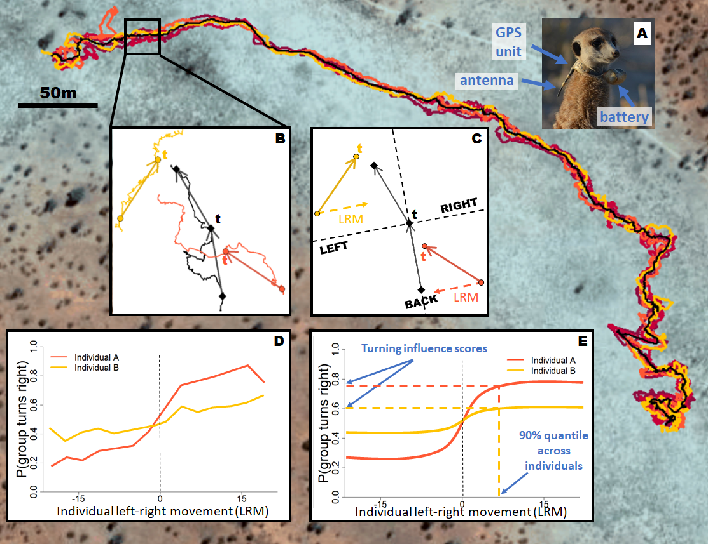
Figure 1. Summary of the data processing pipeline to calculate the turning influence scores of each individual, from collection of individual meerkat trajectories to spatial discretization, modeling of the turning influence curve and computation of the influence score. Background shows the trajectories of six meerkats from group HM17 recorded over a three-hours time period at one fix / second from GPS collars. The black line represents the trajectory of the group centroid over the same time-interval, obtained by averaging the coordinates of every individual in the group at each time step. (A) Picture of a meerkat wearing a custom-made collar recording its movement at high resolution. (B) At a given time t, velocity vectors (solid arrows) are calculated from the points ten meters in the past (centroid and individual tracks) and ten meters in the future (centroid track only). Only the group centroid and two individuals are shown, in yellow and orange, for clarity. (C) The velocity vector of the centroid from the past is used to define an orthonormal basis (group reference frame, dashed lines) relative to which the position and movement of individuals are calculated. Based on the centroid velocity vector from the future, the group is defined as either turning left or turning right at time t (turning left in the example). Individual left-right movement (LRM, dashed arrows) is calculated as the x-component of the individual velocity vectors from the past in the group reference frame. In this example, the orange individual has a positive turning influence at time t, despite being in the back of the group, because it was moving towards the left side of the group before the group turned left. On the other hand, the yellow individual has a negative turning influence at time t, despite being in the front of the group, because it was moving towards the right side of the group before the group turned left. (E) After doing the calculations for every available time step, the probability of the group to turn right is plotted as a function of an individual’s left-right speed. This shows that as individuals move faster towards the right (positive x-values), the probability of the group to turn right increases (and vice-versa), but the extent and rate of the increase varies for different individuals, reflecting differences in influence. Here the orange individual has a higher influence on the rest of the group than the yellow individual. (F) The influence curves are modelled using a modified logistic function, and the 90% quantile of the left-right movement across all individuals of a given group is used to compute a single turning influence score for each individual. The speeding influence score is calculated analogously, using instead the probability of the group to speed up and the difference between group and individual front-back speed (not shown, see main text). Note that in the real analyses, the data for a given individual whose influence is being measured is excluded from the computation of the centroid location and movement, to avoid circularity.

Exploratory analyses showed that the probability of the group to turn right increased sharply as individual movement towards the right increased before plateauing, and conversely for the probability to turn left, resulting in a sigmoid-like curve (Figure 1E and section 7 of the Supplements). A similar shape was observed for speeding influence (see section 7 of the Supplements). For each influence type, we therefore modelled the probability of a binary group response (turn left / right, speed up / slow down) as a function of a continuous individual predictor (movement relative to the group reference frame). Specifically, turning influence is the probability of the group to turn right as a function of an individual’s speed along the group’s left-right axis, and speeding influence is the probability of the group to speed up as a function of the difference speed between an individual and the group along the group’s front-back axis.
To model these probabilities, we fit a modified version of the logistic function to both types of influence, for each individual (equation 1):
$\left(1\right) f\left(x\right)= [α \frac{1}{1+e^{-βx}}] + [γ \left(1-α\right)]$

Here, x represents the individual characteristic (left-right or front-back movement) and f(x) represents the probability of the group turning right or speeding up. α and β are variable parameters which were fit for each individual separately, while γ is a fixed parameter which we set as described below. This modified sigmoidal shape was chosen due to its empirical correspondence with the data, as well as the interpretability of its parameters. In particular, α can be interpreted as the probability that the group is influenced by the focal individual at a given time point, and in practice controls the maximum and minimum height of the curve. β can be interpreted as the logistic growth rate (steepness) of the curve and hence the strength of influence relative to how much an individual moves. γ is the baseline probability of the group either turning right or speeding up. For the turning influence metric, γ was set to 0.5 (assuming an overall equal probability to turn left or right), whereas for speeding influence metric, γ was fixed to the aggregate probability of a given group to speed up across all the data. Because groups tend to accelerate in rapid bursts but decelerate over longer time periods, the overall probability of a group speeding up is lower than the probability of the group slowing down, hence the value of γ ranged from 0.24 to 0.37.

We fit the values of α and β for each influence metric using maximum likelihood estimation, enabling us to define, for each individual, two curves representing its turning and speeding influence. For ease of interpretation and subsequent modeling, we also defined an aggregate “influence score” as the value of the individual’s fitted curve at the 90% quantile of either continuous predictor variables across all individuals of a given group (figure 1F). This influence score therefore corresponds to the probability that the group is positively influenced by the focal individual for a fixed amount of movement (either left/right or front/back) relative to the group centroid. The model fits for each individual are shown in section 7 of the supplements.

To test if there were consistent differences in influence based on individual social status, we fitted binomial GLMMs to predict influence score as a function of status (dominant female, dominant male, adult, sub-adult, juvenile), for both types of influence. Each individual was considered as one data point in the models, and we included group as a random effect to control for non-independence of data within each group. We also conducted post-hoc Tukey tests to compare the influence of each pair of status types (section 6 of the supplements).
Finally, we tested whether speeding and turning influence were correlated with one another by computing the Spearman multilevel correlation with group as a random factor.

Proportion of time in the front:
To assess whether individuals differ in their propensity to be at the front of the group, we quantified for each individual the distribution of front-back position relative to the group direction of travel. We also calculated the proportion of time each individual spent in the front half of the group, as a simple metric of ‘frontness’, to allow comparison with our influence scores. At time t, a given individual was considered in the front half of the group if its front-back position was positive. To quantify the variation in the propensity to be in the front between individuals and across groups, we computed the proportion of time points an individual was in the front half in time segments of one hour.
To test whether individuals at the front of groups have greater influence, we computed Spearman multilevel correlations between the total proportion of time spent in the front for each individual and their turning and speeding influence scores, controlling for group as a random factor.

RESULTS
Turning influence and speeding influence scores across social statuses:
We found that individuals varied substantially in their influence on group direction and speed (figure 2 and section 7 of the supplements). There was a significant effect of status on turning influence score (figure 5a, F = 5.19 ; DF = 40 ; p-value = 0.0018), with the dominant female’s score consistently being the highest or second highest of her group across all groups. Post-hoc Tukey tests (see section 6 of the Supplements) showed that the score of dominant females was overall significantly higher than the scores of all subordinate status (i.e. non-dominant adults, yearlings and sub-adults), whereas the score of the dominant male was not significantly different from the scores of subordinates.
There was also a significant difference between the speeding influence score of different statuses, with group taken into account as a random factor (figure 5b, F = 3.95 ; DF = 40 ; p-value = 0.0086). Post-hoc Tukey tests (see section 2 of the Supplements) showed that the score of dominant females was significantly higher than the score of yearlings and sub-adults but was not significantly different from the score of dominants males and non-dominant adults. The score of the dominant male was not significantly different from the scores of subordinates.
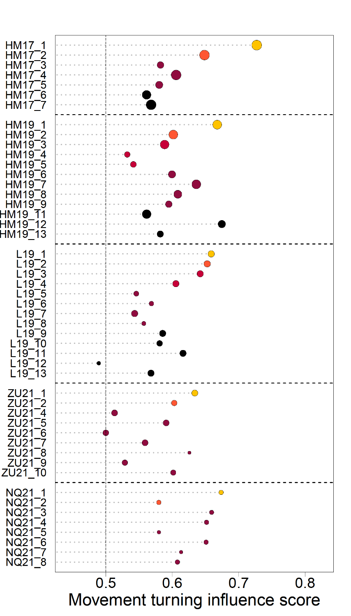
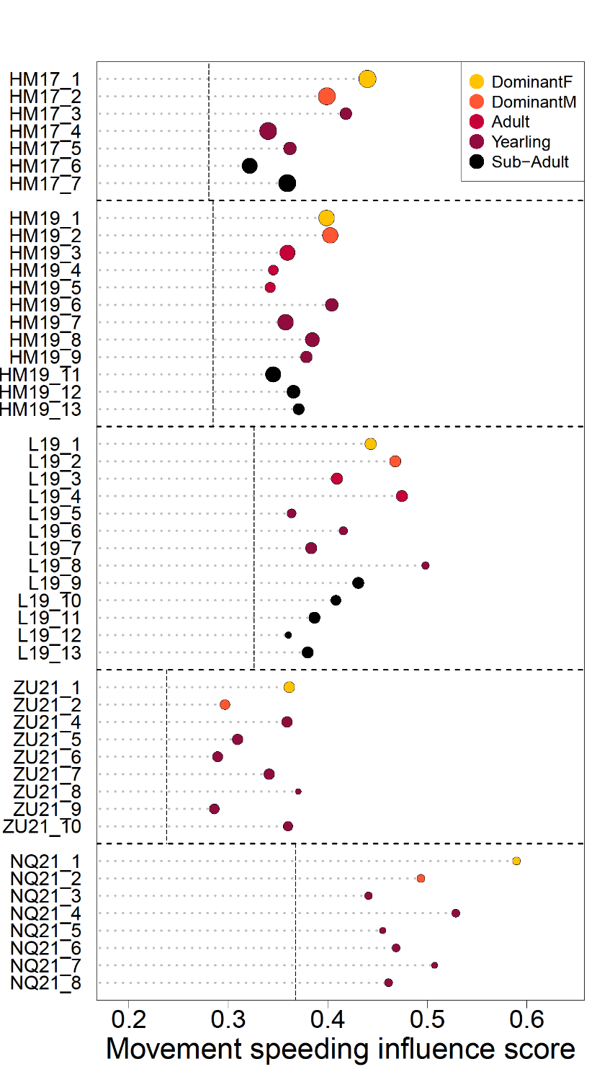
Figure 2. Predicted influence scores for each recorded individual (colored dots) in the 5 study groups (vertical axis). Dot color indicates individual status as shown in the legend, dot size is proportional to the quantity of data available. Dotted vertical lines represent baseline probabilities for the outcome of group decision (50% percent chance of turning left or right for turning influence and overall probability to speed up for each group for speeding influence). (A) Turning influence score represents the probability that the group turns toward the same direction (left or right) that individual was moving to. (B) Speeding influence score represents the probability that the group speeds up after that individual had sped up towards the front of the group.
A
B

There was a positive correlation between turning and speeding influence scores (figure 5, F=14.62 ; DF = 47 ; p-value < 0.001).

Influence vs time spent in the front:
We found that the association between the time spent in the front half of the group and the social status of individuals varied between groups (figure 6), with some showing a trend towards more time spent in the front by the dominant female (HM2017, HM2019, NQ2021), one showing the opposite effect (ZU21) and one no effect (L2019). The dominant male was more in the back half of the group in all but one deployment (L2019).
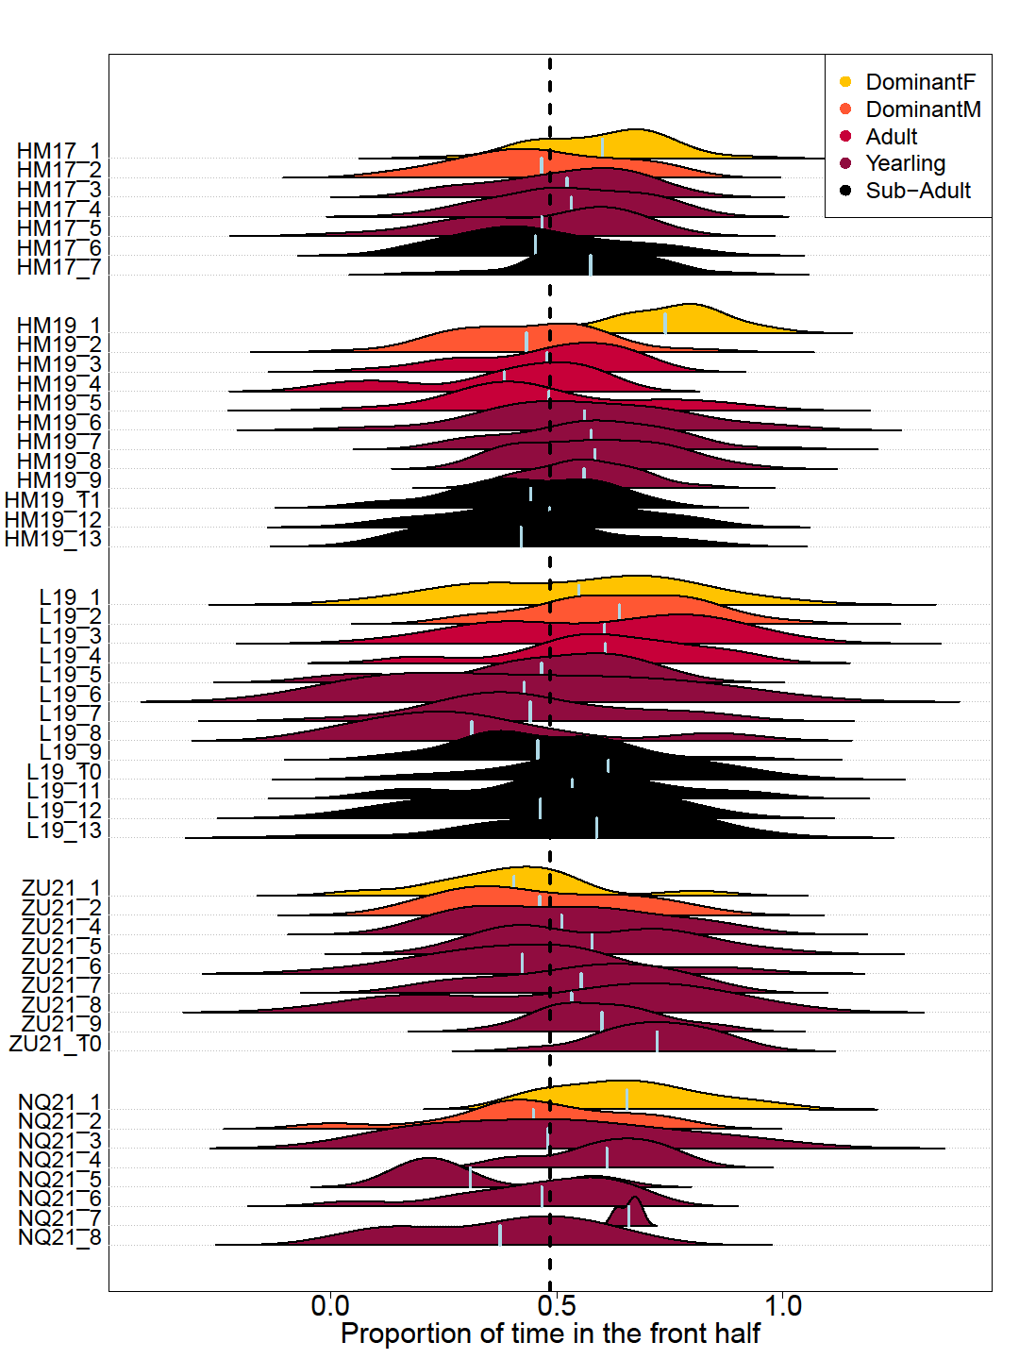
Figure 3. Distribution of the proportion of time steps spent in the front half of the group over one-hour time periods, for each individual in the 5 study groups (vertical axis). Shape color indicates individual status as shown in the legend. Light vertical lines within each shape indicates the overall mean proportion of time spent in the front half of the group for that individual. Vertical dotted line indicates equal amount of time spent in the front and in the back half of the group.
With group controlled for as a random factor, we found weak positive correlations between turning influence scores and speeding influence scores (r=0.5, p < 0.001, figure 4.a), turning influence scores and overall proportion of time spent in the front half (r=0.37, p=0.008, figure 4.b), and speeding influence scores and overall proportion of time spent in the front half (r=0.33, p=0.02, figure 4.c).

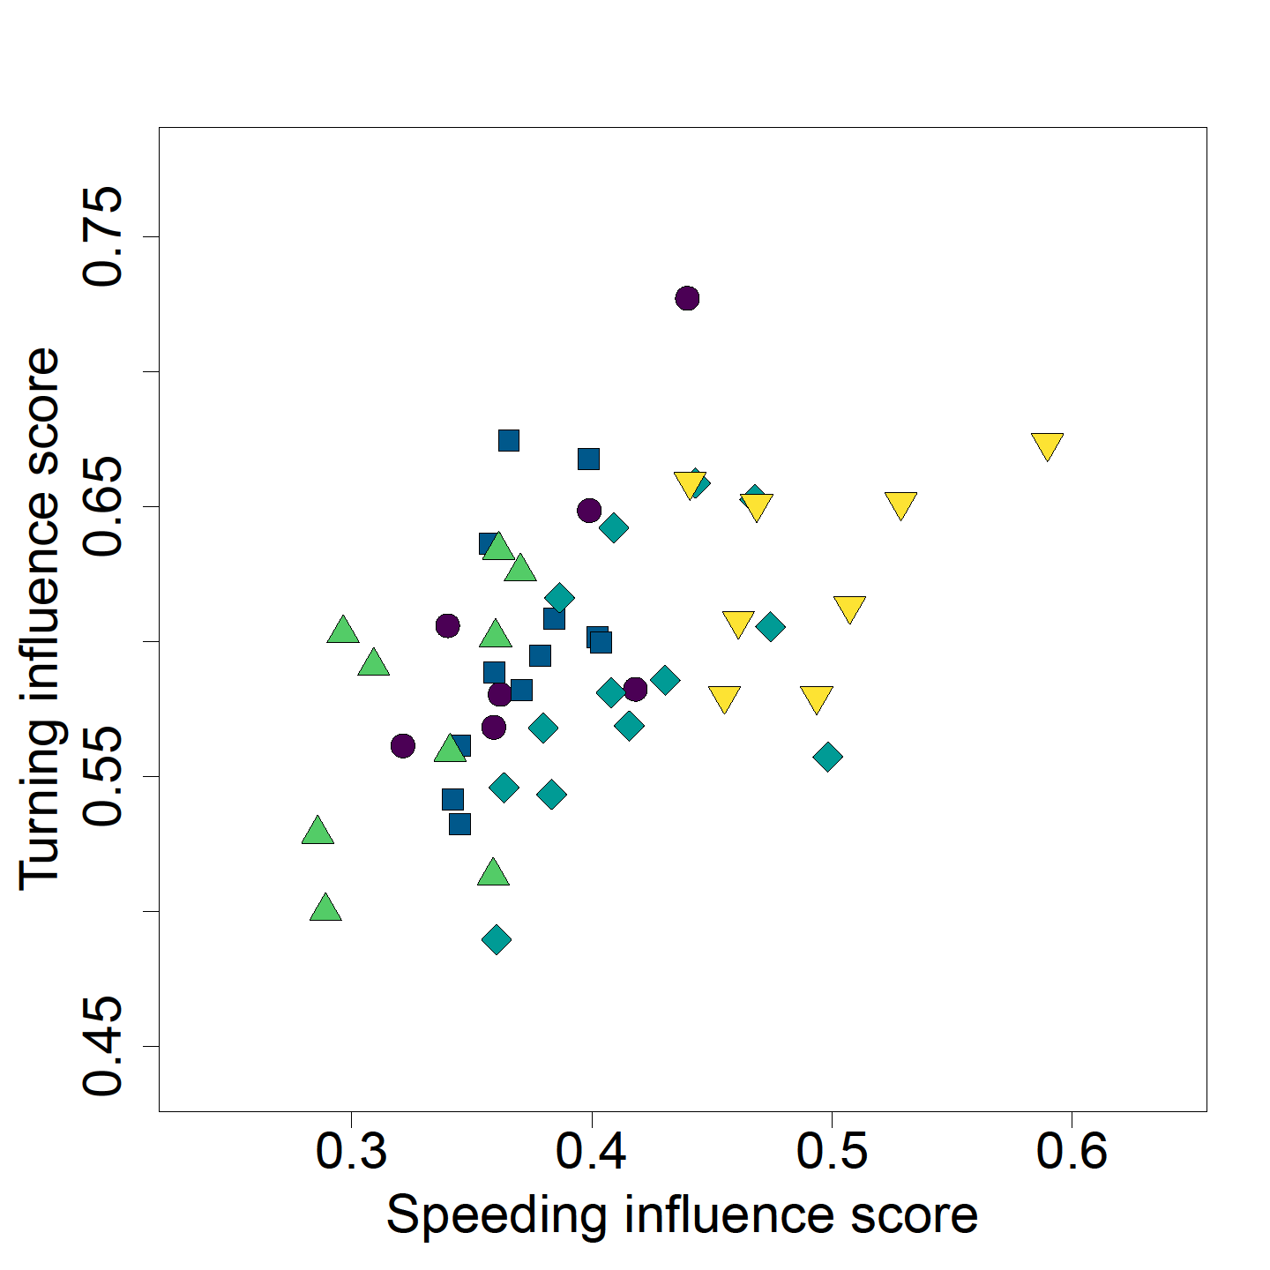
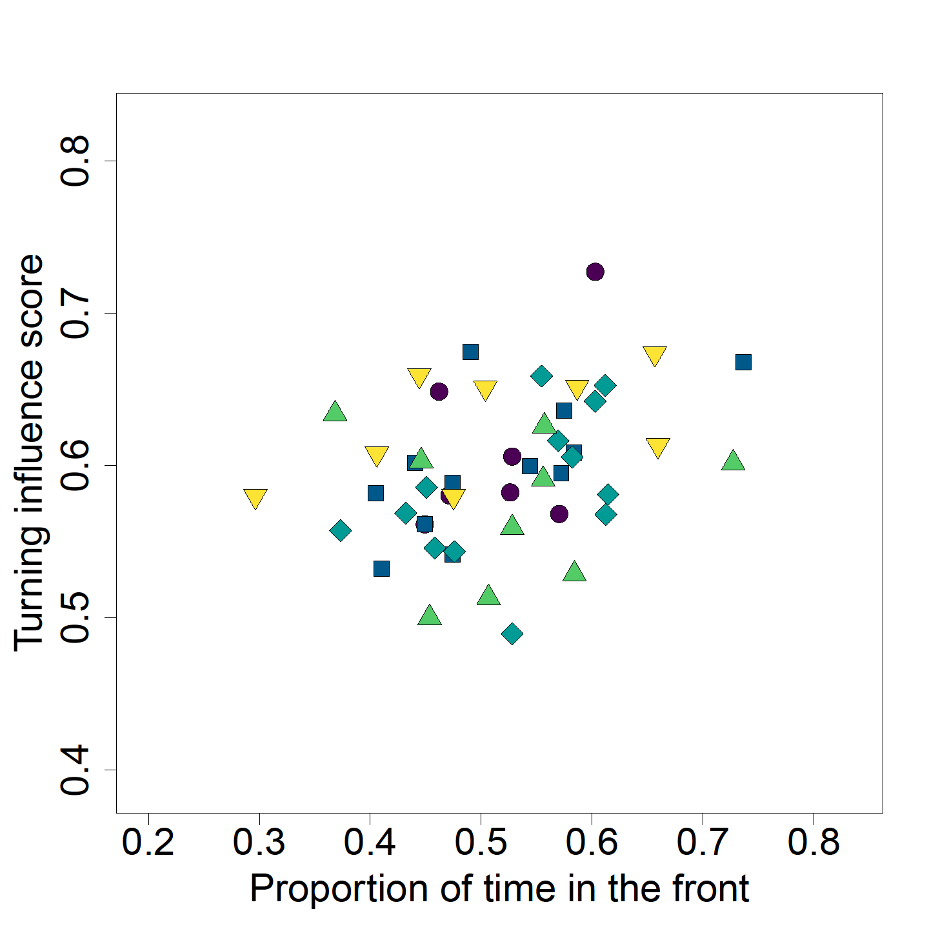
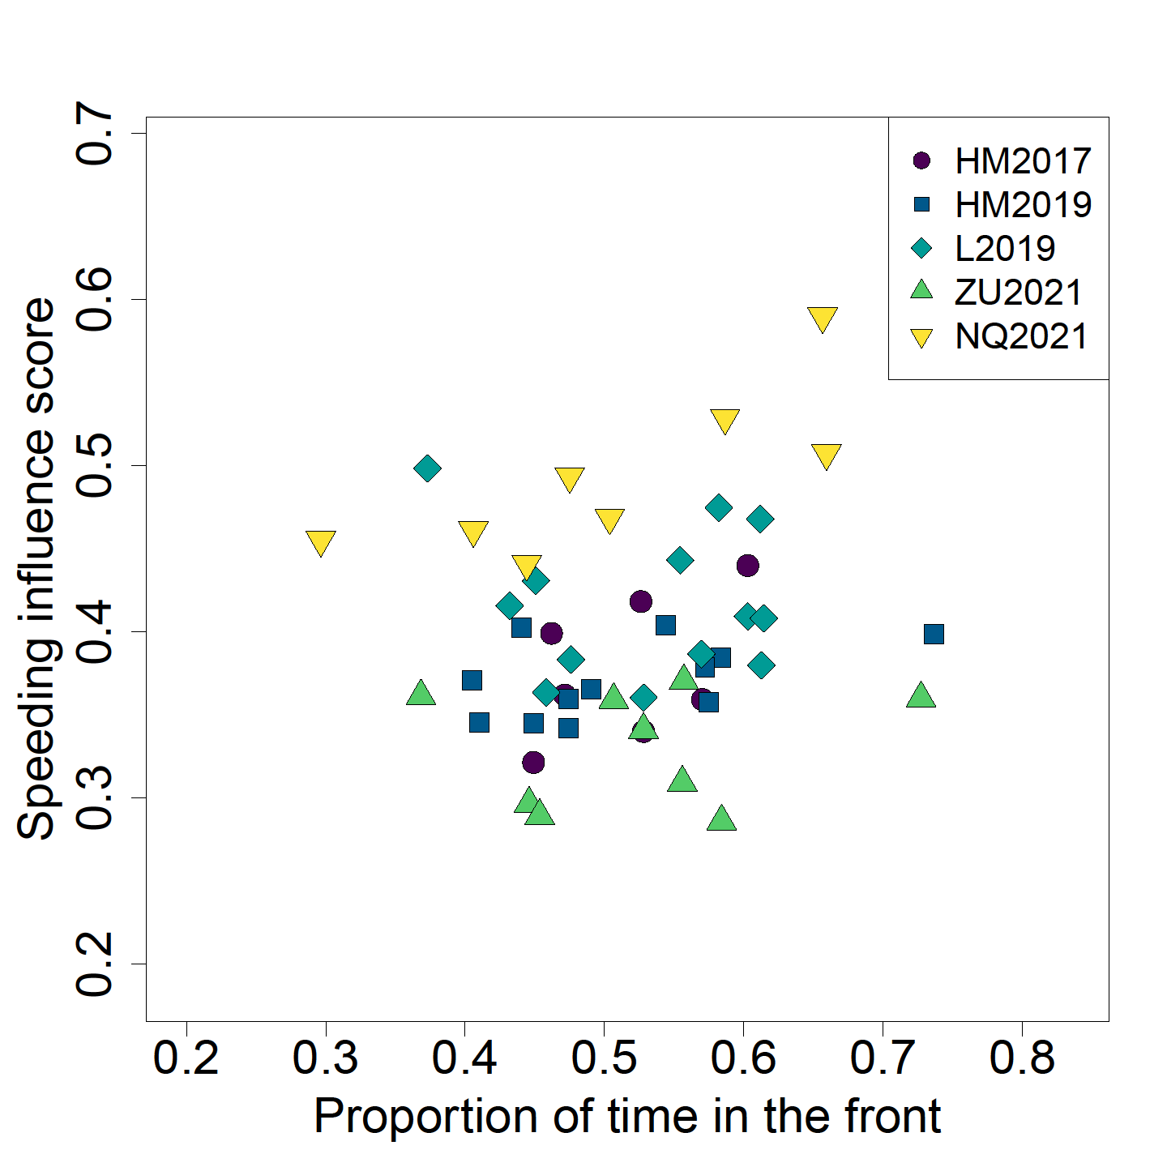
Figure 4. Correlation between the different individual metrics. (A) Turning influence as a function of speeding influence. (B) Turning influence as a function of proportion of time spent in the front. (C) Speeding influence as a function of proportion of time spent in the front. Each dot represents one individual, with color and shape indicating group membership, as shown in legend.
A
B
C

DISCUSSION
Using a suite of metrics to quantify influence, we analyze high-resolution tracking data across five different meerkat social groups to reveal how influence is distributed. Individual influence over group movement has been assessed in multiple ways in social mammal species, with socially dominant individuals, and particularly dominant females, being frequently the most influential individuals (Holekamp et al. 2000; Barelli et al. 2008; Van Belle et al. 2013; Tokuyama and Furuichi 2017). Here, we found that meerkat’s likelihood to influence the group’s direction increases with the speed at which they move in particular directions, and that individuals differed substantially in the amount of influence that their movement exerted on the group. More importantly, we found that these differences were linked with the social status of individuals within their group, with each group’s dominant female being a clear outlier in terms of turning influence across the five social groups we monitored. Dominant females had significantly higher turning influence, meaning that the rest of the group was more likely to follow their movement directions than that of any of the other statuses. In contrast, dominant males did not appear to have outsized influence relative to other adults in their social groups. In mammals, the finding that dominant females appear to wield more influence than dominant males is often interpreted in light of the higher energetic requirements of reproduction in females, with leadership potentially providing females with priority of access to higher-quality resources, therefore compensating the costs of pregnancy and/or lactation[ref]. The extent to which these arguments also apply to meerkats is debatable. Indeed, meerkats are notable cooperative breeders (Clutton-Brock et al. 1998), so even though dominant females are usually the only ones in their group to bear pups, after birth the cost of reproduction is distributed among group members. In our study, we also found that dominant females wielded outsized influence over group direction regardless of their reproductive status (see table S2 in the Supplements). An alternative explanation could be that experience drives influence patterns, with individuals more experienced in the territory more often influencing the group direction. Meerkat group territories usually vary little over the course of individuals’ lives (Kranstauber et al. 2019), therefore individuals who have spent more time within a given group might have the most experience navigating within the group’s home range. Because meerkat males disperse when they reach sexual maturity, dominant males, though often older than their female counterparts, are typically non-natal and hence have usually not spent as much time in the group territory (S.P. Doolan and Macdonald 1996; Griffin et al. 2003; Mares et al. 2014). As a consequence, dominant females are usually the eldest natal individuals of their groups. This was the case in HM19, L19 and ZU21. In HM17 and NQ21, the dominant male (HM17_2) and two subordinate individuals (NQ21_3 and NQ21_4) respectively, had spent the same amount of time in the group as the dominant female (see table S2 in Supplements), and it is noteworthy that all three had fairly high turning influence scores (see figure 2). However, according to this reasoning, we would expect higher influence in older subordinate statuses than in younger ones, which was not the case in our data. It is therefore likely that experience is not the only factor explaining the turning influence differences observed.
When moving cohesively, social animal groups constantly have to make decisions regarding where to go and how fast to go there. Because these decisions happen simultaneously, it is non-trivial to assess individual contribution to these two decision types, and to our knowledge few studies have attempted it in the wild. The method we used was designed specifically to not only infer individual influence on group direction, but also on group speed. We found that though individuals with high influence on group turning also tended to have high influence on group speed, there were less striking intra-group differences between social statuses in terms of speeding influence. In particular, all adult statuses (dominant female, dominant male and other adults) had a similar chance of speeding the group up when they were moving faster than the centroid, or slowing it down when moving slower than the centroid. The dominant female therefore seems to have more influence over the direction of travel of the group, than over its speed. Interestingly, this reflects recent results on sleep site selection in meerkats. Strandburg-Peshkin et al. (2020), looked at the selection of sleeping burrows (influence on direction) found a stronger influence of the dominant female, whereas Gall et al. (2017), which looked at the timing of return to the sleeping burrow (influence on speed) did not. Decisions about direction of movement and decisions about speed of movement usually differ in that the former are discrete whereas the latter are continuous (Conradt and Roper 2010). In the case of meerkats, this means that contrary to timing decisions, bad/suboptimal decisions regarding the direction of movement could end up being very costly for all individuals in the groups, as they could end up in a location with little food, or no sleeping burrows, or in rival territories. Thus, it makes sense that experienced individuals, such as the dominant females of the group, are more likely to influence decisions involving directions than decisions involving speed. Given our results, influence over group speed could be either distributed, with all or most adults contributing to the decision to speed up or not at a given moment, or varying in time between group members, with individuals taking turns influencing others to speed up or slow down. Unfortunately, our methodology does not allow us to disentangle between these two options. Because group speed could have repercussions on an individuals’ ability to locate food, and because quorum mechanisms, akin to a voting process by which a certain threshold of individuals giving a specific type of call is required for the group to start moving, have already been shown in meerkats (Bousquet et al. 2011), in future work it could be very interesting to incorporate data about individual foraging success, as well as vocalizations, within our influence framework, to further our understanding of the interactions between these aspects. These results highlight the fact that influence is not an absolute notion, with individuals exerting influence in one particular context not necessarily exerting it in others.
The tendency to be in the front of the group is also often taken as a proxy for leadership in studies of group movement. Here we did find a positive correlation between turning influence and proportion of time spent in the front half of the group. However, when looking specifically at dominant females (with the highest turning influence within their group), we see that they are not necessarily more in the front than other members of the group. In particular, in L19, the dominant female spent a similar amount or less time in the front than many other individuals in her group, and in ZU21, she was the individual who spent the least amount of time in the front of the group, despite both of these dominant females having the highest turning influence scores of their groups. These results highlight that individuals in moving social groups do not necessarily need to be at the front position in order to influence group direction. Being in the front is most likely to be linked with influence in environments where visibility is high and in species where information is transferred primarily through vision (e.g. fish, Rosenthal et al., 2015; Strandburg-Peshkin et al., 2013). However in the meerkats’ habitat, tall sour grass or bushes often impede visibility, and meerkats are known to use a variety of vocalizations to coordinate movement (Bousquet et al. 2011; Reber et al. 2013; Manser et al. 2014; Gall and Manser 2017). Thus, they have the potential to convey information, and therefore influence others, regardless of their location relative to the other group members. This decoupling of front position and influence over direction highlights, that depending on the species, the ordering of individuals along the axis of movement alone might not be a reliable metric to infer influence and should be used in complement with other metrics. Moreover, understanding when and how individuals are able to exert influence from the back of groups, and how this is linked to the mechanisms of information transfer employed, are important questions for future work. Interestingly, in our data the one dominant female that spent more time in the back (group ZU21) had by far the longest tenure at the time of data collection amongst dominant females of our study (104 weeks against 38 weeks maximum, see table S2 in Supplements). This suggests the intriguing possibility that as a female’s dominance becomes more established within a group, she might become more able to influence the group from any position.
CONCLUSION
Overall our results show that dominant females have the most influence over the direction of travel but not necessarily over speed of travel, highlighting the importance of disentangling these two components of influence even in groups where both operate concurrently. Furthermore, the finding that the most influential individuals are not always the ones located in the front of the group emphasizes the need to critically evaluate the common assumption that those at the front take the lead. The results presented here highlight the complexity of the concept of influence and demonstrate the need to study it from different perspectives across multiple groups to begin to reveal a more complete understanding of collective decision-making in animal societies.

The methodological approach developed here is species-general and could be applied broadly across different species, or under different environmental conditions,. Because our approach by design captures influence aggregated over time, it could be interesting in future work to contrast it with complementary approaches, for instance ones that identify particular events in the trajectory such as sharp changes in direction or increases in speed during movement, in order to gain a more complete picture of the distribution and variability of influence in social groups. The method could also be used in combination with other features, such as vocalizations, to assess how such features impact influence dynamics.

ACKNOWLEDGMENTS
We thank the Kalahari Research Trust for permission to work at the Kuruman River Reserve, and the neighboring farmers to use their land. We also thank Tim Clutton-Brock for the organization of the field site, as well as managers, volunteers, students and staff at the Kalahari Meerkat Project for maintaining the habituation and collecting long-term data, as well as for assistance prior to and during data collection. Many thanks to Rebecca Shaefer, Pauline Toni and Camille Lysemna who worked as field assistant during some of the field seasons. Finally, we thank Andrew Gersick, Ben Hirsh, Kay Holekamp, Frants Jensen, Marie Roch from the Communication and Coordination Across Scales project, Alison Ashbury, Grace Davis and members of the Communication and Collective Movement group at the Max Planck Institute of Animal Behavior in Constance for helpful feedback during the elaboration of this paper.

ADDITIONAL INFORMATION
Competing interests
The authors declare no competing interests.

Funding
This work was supported by HFSP award RGP0051/2019 to ASP and MM and funded by the Deutsche Forschungsgemeinschaft (DFG, German Research Foundation) under Germany's Excellence Strategy – EXC 2117 – 422037984. ASP received additional support from the Gips-Schüle Stiftung and the Max Planck Institute of Animal Behavior. MM was funded by the University of Zurich. The long-term research on meerkats is currently supported by funding from the European Research Council (ERC) under the European Union's Horizon 2020 research and innovation program (no. 742808 and no. 294494) and a grant from the Natural Environment Research Council (grant NE/G006822/1) to T.C.-B as well as by grants from the University of Zurich to M.B.M. and the MAVA Foundation.

Ethics
All research was conducted under the permission of the ethical committee of Pretoria University, South Africa (permit number: EC031-17). We would like to thank the Northern Cape Department of Environment and Nature Conservation, South Africa for permission to conduct the research (FAUNA 1020/2016).

Author contributions
BA, VD, GG and ASP collected the data, with support from MM. MM organized the collection of the individualized longterm data (LH data) and the habituation of the study groups. BA, VHS and ASP analyzed and interpreted the data. BA wrote the manuscript, with inputs and revisions from all authors.
BIBLIOGRAPHY
Barelli C, Reichard U, Boesch C, Heistermann M. 2008. Female white-handed gibbons (Hylobates lar) lead group movements and have priority of access to food resources. Behaviour. 145(7):965–981. doi:10.1163/156853908784089243.
Boinski S. 2000. Social Manipulation Within and Between Troops Mediate Primate Group Movement. In: Boinski S, editor. On the Move: How and Why Animals Travel in Groups. Chicago, IL: University of Chicago Press. [accessed 2022 Jan 12]. https://press.uchicago.edu/ucp/books/book/chicago/O/bo3618301.html.
Bousquet CAH, Manser MB. 2011. Resolution of experimentally induced symmetrical conflicts of interest in meerkats. Animal Behaviour. 81(6):1101–1107. doi:10.1016/j.anbehav.2011.02.030.
Bousquet CAH, Sumpter DJT, Manser MB. 2011. Moving calls: a vocal mechanism underlying quorum decisions in cohesive groups. Proceedings of the Royal Society of London B: Biological Sciences. 278(1711):1482–1488. doi:10.1098/rspb.2010.1739.
Byrne RW. 2000. How Monkeys Find Their Way: Leadership, Coordination, and Cognitive Maps of African Baboons. In: Boinski S, Garber PA, editors. On the Move: How and Why Animals Travel in Groups. Chicago, IL: University of Chicago Press. [accessed 2022 Jan 12]. https://press.uchicago.edu/ucp/books/book/chicago/O/bo3618301.html.
Clutton-Brock TH, Brotherton PNM, O’Riain MJ, Griffin AS, Gaynor D, Kansky R, Sharpe L, McIlrath GM. 2001. Contributions to cooperative rearing in meerkats. Animal Behaviour. 61(4):705–710. doi:10.1006/anbe.2000.1631.
Clutton-Brock TH, Gaynor D, Kansky R, MacColl ADC, McIlrath G, Chadwick P, Brotherton PNM, O’Riain JM, Manser M, Skinner JD. 1998. Costs of cooperative behaviour in suricates (Suricata suricatta). Proceedings of the Royal Society B: Biological Sciences. 265(1392):185–190. doi:10.1098/rspb.1998.0281.
Clutton-Brock TH, Maccoll A, Chadwick P, Gaynor D, Kansky R, Skinner JD. 1999. Reproduction and survival of suricates (Suricata suricatta) in the southern Kalahari. African Journal of Ecology. 37(1):69–80. doi:10.1046/j.1365-2028.1999.00160.x.
Conradt L, Roper TJ. 2005. Consensus decision making in animals. Trends in Ecology & Evolution. 20(8):449–456. doi:10.1016/j.tree.2005.05.008.
Conradt L, Roper TJ. 2009. Conflicts of interest and the evolution of decision sharing. Philos Trans R Soc Lond B Biol Sci. 364(1518):807–819. doi:10.1098/rstb.2008.0257.
Conradt L, Roper TJ. 2010. Deciding group movements: where and when to go. Behavioural processes. 84:675–677. doi:10.1016/j.beproc.2010.03.005.
Doolan S, Macdonald D. 1996. Diet and foraging behaviour of group living meerkats, Suricata suricatta, in the southern Kalahari. Journal of Zoology. 239:697–716.
Doolan SP, Macdonald DW. 1996. Dispersal and extra-territorial prospecting by slender-tailed meerkats (Suricata suricatta) in the south-western Kalahari. Journal of Zoology. 240(1):59–73. doi:10.1111/j.1469-7998.1996.tb05486.x.
Doolan SP, Macdonald DW. 1997. Breeding and juvenile survival among slender-tailed meerkats (Suricatu suricatta) in the south-western Kalahari: ecological and social influences. Journal of Zoology. 242(2):309–327. doi:10.1111/j.1469-7998.1997.tb05804.x.
Engesser S. 2011. Function of ‘close’ calls in a group foraging carnivore, Suricata suricatta.
Engesser S, Manser MB. 2022. Collective close calling mediates group cohesion in foraging meerkats via spatially determined differences in call rates. Animal Behaviour. 185:73–82. doi:10.1016/j.anbehav.2021.12.014.
Farine DR, Strandburg-Peshkin A, Couzin ID, Berger-Wolf TY, Crofoot MC. 2017. Individual variation in local interaction rules can explain emergent patterns of spatial organization in wild baboons. Proc R Soc B. 284(1853):20162243. doi:10.1098/rspb.2016.2243.
Gall GEC, Manser MB. 2017. Group cohesion in foraging meerkats : follow the moving ‘ vocal hot spot ’. Royal Society Open Science.
Gall GEC, Strandburg-Peshkin A, Clutton-brock T, Manser MB. 2017. As dusk falls : collective decisions about the return to sleeping sites in meerkats. 132:91–99.
Garland J, Berdahl AM, Sun J, Bollt EM. 2018. Anatomy of leadership in collective behaviour. Chaos. 28(7):075308. doi:10.1063/1.5024395.
Giuggioli L, McKetterick TJ, Holderied M. 2015. Delayed Response and Biosonar Perception Explain Movement Coordination in Trawling Bats. PLOS Computational Biology. 11(3):e1004089. doi:10.1371/journal.pcbi.1004089.
Griffin AS, Pemberton JM, Brotherton PNM, McIlrath G, Gaynor D, Kansky R, O’Riain J, Clutton-Brock TH. 2003. A genetic analysis of breeding success in the cooperative meerkat (Suricata suricatta). Behavioral Ecology. 14(4):472–480. doi:10.1093/beheco/arg040.
Herbert-Read JE, Perna A, Mann RP, Schaerf TM, Sumpter DJT, Ward AJW. 2011. Inferring the rules of interaction of shoaling fish. PNAS. 108(46):18726–18731. doi:10.1073/pnas.1109355108.
Holekamp KE, Boydston EE, Smale L. 2000. Group Tarvel in Social Carnivores. In: Boinski S, Garber PA, editors. On the Move. University of Chicago Press.
Jolles JW, Boogert NJ, Sridhar VH, Couzin ID, Manica A. 2017. Consistent Individual Differences Drive Collective Behavior and Group Functioning of Schooling Fish. Current Biology. 27(18):2862-2868.e7. doi:10.1016/j.cub.2017.08.004.
Katz Y, Tunstrøm K, Ioannou CC, Huepe C, Couzin ID. 2011. Inferring the structure and dynamics of interactions in schooling fish. PNAS. 108(46):18720–18725. doi:10.1073/pnas.1107583108.
Kerth G, Ebert C, Schmidtke C. 2006. Group decision making in fission–fusion societies: evidence from two-field experiments in Bechstein’s bats. Proceedings of the Royal Society B: Biological Sciences. 273(1602):2785–2790. doi:10.1098/rspb.2006.3647.
King AJ, Douglas CMS, Huchard E, Isaac NJB, Cowlishaw G. 2008. Dominance and Affiliation Mediate Despotism in a Social Primate. Current Biology. 18(23):1833–1838. doi:10.1016/j.cub.2008.10.048.
Kranstauber B, Gall GEC, Vink T, Clutton‐Brock T, Manser MB. 2019. Long-term movements and home-range changes: Rapid territory shifts in meerkats. Journal of Animal Ecology. n/a(n/a). doi:10.1111/1365-2656.13129. [accessed 2019 Dec 19]. https://besjournals.onlinelibrary.wiley.com/doi/abs/10.1111/1365-2656.13129.
Lewis JS, Wartzok D, Heithaus MR. 2011. Highly dynamic fission–fusion species can exhibit leadership when traveling. Behav Ecol Sociobiol. 65(5):1061–1069. doi:10.1007/s00265-010-1113-y.
Manser MB, Clutton‐Brock TH. 2016. Meerkats: cooperative breeding in the Kalahari. In: Koenig WD, Dickinson JL, editors. Cooperative Breeding in Vertebrates. Cambridge University Press.
Manser MB, Jansen DAWAM, Graw B, Hollén LI, Bousquet CAH, Furrer RD, le Roux A. 2014. Vocal Complexity in Meerkats and Other Mongoose Species.
Mares R, Bateman AW, English S, Clutton-Brock TH, Young AJ. 2014. Timing of predispersal prospecting is influenced by environmental, social and state-dependent factors in meerkats. Animal Behaviour. 88:185–193. doi:10.1016/j.anbehav.2013.11.025.
Montanari D, O’Hearn WJ, Hambuckers J, Fischer J, Zinner D. 2021. Coordination during group departures and progressions in the tolerant multi-level society of wild Guinea baboons (Papio papio). Sci Rep. 11(1):21938. doi:10.1038/s41598-021-01356-6.
Nagy M, Ákos Z, Biro D, Vicsek T. 2010. Hierarchical group dynamics in pigeon flocks. Nature. 464(7290):890–893. doi:10.1038/nature08891.
Papageorgiou D, Farine DR. 2020. Shared decision-making allows subordinates to lead when dominants monopolize resources. Science Advances. 6(48):eaba5881. doi:10.1126/sciadv.aba5881.
Pettit B, Ákos Z, Vicsek T, Biro D. 2015. Speed Determines Leadership and Leadership Determines Learning during Pigeon Flocking. Current Biology. 25(23):3132–3137. doi:10.1016/j.cub.2015.10.044.
Reber SA, Townsend SW, Manser MB. 2013. Social monitoring via close calls in meerkats. Proceedings of the Royal Society B: Biological Sciences. 280(1765):20131013–20131013. doi:10.1098/rspb.2013.1013.
Rosenthal SB, Twomey CR, Hartnett AT, Wu HS, Couzin ID. 2015. Revealing the hidden networks of interaction in mobile animal groups allows prediction of complex behavioral contagion. PNAS. 112(15):4690–4695. doi:10.1073/pnas.1420068112.
Smith JE, Estrada JR, Richards HR, Dawes SE, Mitsos K, Holekamp KE. 2015. Collective movements, leadership and consensus costs at reunions in spotted hyaenas. Animal Behaviour. 105:187–200. doi:10.1016/j.anbehav.2015.04.023.
Strandburg-Peshkin A, Clutton-Brock T, Manser MB. 2020. Burrow usage patterns and decision-making in meerkat groups. Behavioral Ecology. 31(2):292–302. doi:10.1093/beheco/arz190.
Strandburg-Peshkin A, Farine DR, Couzin ID, Crofoot MC. 2015. GROUP DECISIONS. Shared decision-making drives collective movement in wild baboons. Science. 348(6241):1358–1361. doi:10.1126/science.aaa5099.
Strandburg-Peshkin A, Papageorgiou D, Crofoot MC, Farine DR. 2018. Inferring influence and leadership in moving animal groups. Philosophical transactions of the Royal Society of London Series B, Biological sciences. 373(1746):20170006–20170006. doi:10.1098/rstb.2017.0006.
Strandburg-Peshkin A, Twomey CR, Bode NWF, Kao AB, Katz Y, Ioannou CC, Rosenthal SB, Torney CJ, Wu HS, Levin SA, et al. 2013. Visual sensory networks and effective information transfer in animal groups. Current Biology. 23(17):R709–R711. doi:10.1016/j.cub.2013.07.059.
Tokuyama N, Furuichi T. 2017. Leadership of old females in collective departures in wild bonobos (Pan paniscus) at Wamba. Behav Ecol Sociobiol. 71(3):55. doi:10.1007/s00265-017-2277-5.
Townsend SW, Rasmussen M, Clutton-Brock T, Manser MB. 2012. Flexible alarm calling in meerkats: the role of the social environment and predation urgency. Behavioral Ecology. 23(6):1360–1364. doi:10.1093/beheco/ars129.
Van Belle S, Estrada A, Garber PA. 2013. Collective group movement and leadership in wild black howler monkeys (Alouatta pigra). Behav Ecol Sociobiol. 67(1):31–41. doi:10.1007/s00265-012-1421-5.

